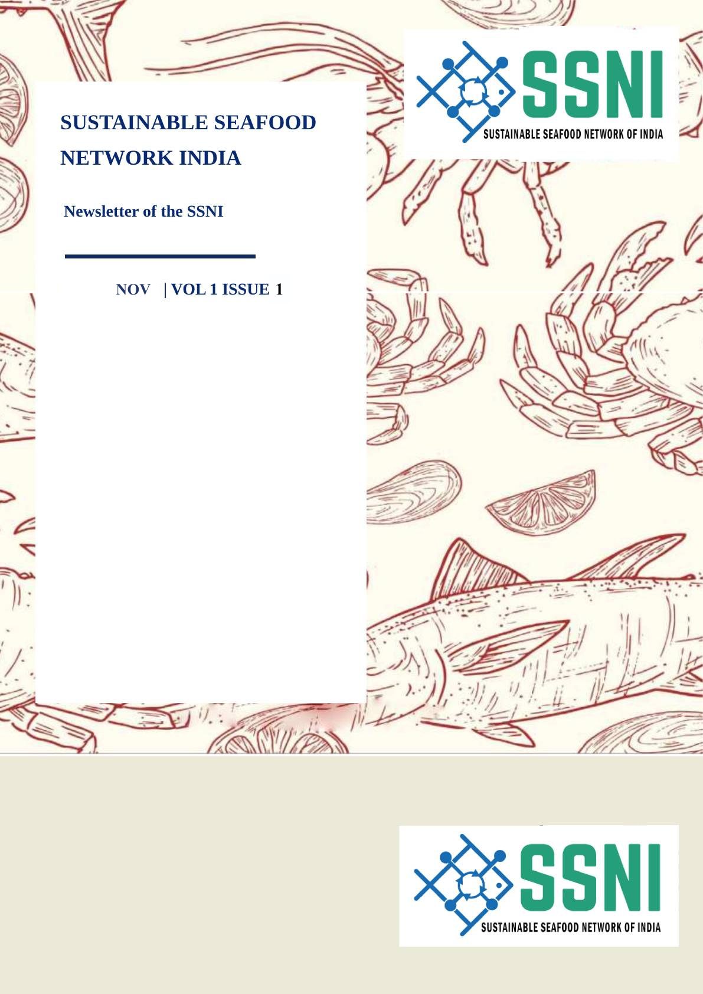

This year, World Fisheries Day is being observed with the theme “India’s Blue Transformation: Strengthening Value Addition in Seafood Exports.” The celebrations carry a global character, with India hosting participants from across the country and overseas, including delegations from 27 nations, reflecting the country’s growing leadership and partnerships in the Blue Economy.

As part of the event, the Department of Fisheries released the National Framework on Traceability in Fisheries and Aquaculture, a major step toward ensuring safe, sustainable, and globally compliant seafood supply chains with enhanced market access. Several key interventions for sustainable fisheries and aquaculture were launched, including SOPs for Mariculture, Guidelines for Smart and Integrated Harbours, Fish Landing Centres, Reservoir Fisheries Management, and a Compendium of Coastal Aquaculture Guidelines.

Key Highlights:

Theme (2025): “India’s Blue Transformation: Strengthening Value Addition in Seafood Exports.”
Total fish production has more than doubled from 96 lakh tonnes (2013–14) to 195 lakh tonnes (2024–25).
Marine product exports increased by 11.08%, from US$ 0.81 billion (Oct 2024) to US$ 0.90 billion (Oct 2025).
Ranking: India is the second-largest fish-producing country and among the top shrimp producers globally.
Major Government Initiatives:
Launch of the National Framework on Traceability to ensure safe, transparent, and globally compliant seafood supply chains.
Implementation of the Sustainable Harnessing of Fisheries in the EEZ Rules, promoting environmentally responsible deep-sea fishing and prioritizing access for Fishermen Cooperatives and FFPOs—enhancing income opportunities for small-scale fishers.
Introduction of ReALCRaft, a digital platform enabling online registration, licensing, e-payments, vessel data updates, and integrated inspections for paperless fisheries governance.
Deployment of NABHMITRA, a two-way satellite communication system for small vessels (<20 m), providing real-time tracking, SOS alerts, and weather updates, significantly improving fisher safety and coordination with coastal authorities.
During the World Fisheries Day 2025 celebrations, Technical Session I spotlighted India’s Blue Transformation under the theme “Enhancing Growth through Value Addition in Fisheries and Aquaculture.” The dialogue brought together researchers and innovators to explore diversification of value-added seafood products and strengthen branding and certification for global competitiveness.

Contribution of MSC India (Dr. Ranjit Suselan):

Dr. Ranjit Suselan presented and discussed the critical requirements that Government of India needs to incorporate into its policies for the effective implementation of sustainability standards and MSC Certification for value-added products.

